**DR N CHANDRA & PARTNERS**

NORTH ROAD SUITE

1ST FLOOR

RAVENSTHORPE HC

NETHERFIELD ROAD

RAVENSTHORPE

**DEWSBURY WF13 3JY**

**TEL: 01924 767 101**

PRACTICE CATCHMENT AREA INCLUDES THE FOLLOWING POST CODES

**WF13 RAVENSTHORPE**

**WF12 DEWSBURY**

**WF14 MIRFIELD**

**WF16 HECKMONDWIKE**

**WF15 LIVERSEDGE**



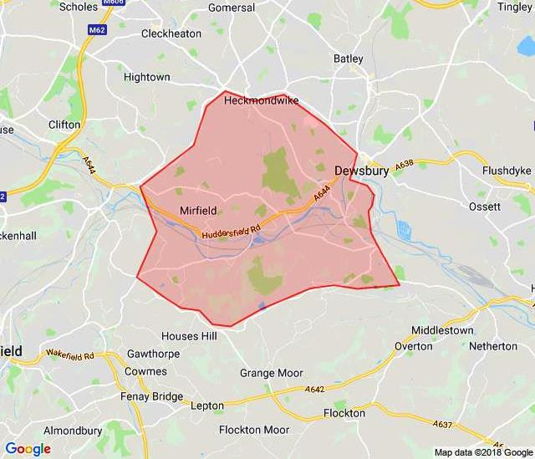

**If you are unsure if you reside in our catchment area please contact Rachael Atkinson our patient registrations officer on 01924 767 097 and ask for her on ext 1816.**